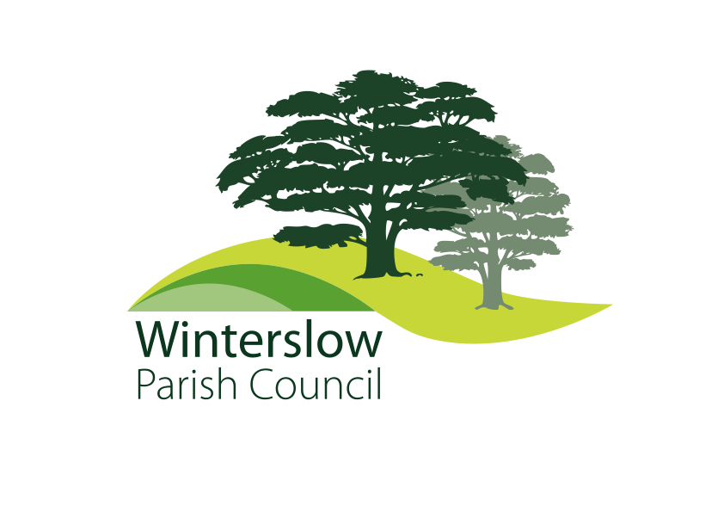

**Minutes of the Winterslow Parish Council February monthly meeting held at Winterslow Village Hall on Monday 3rd February 2025 at 7.30 hrs.**

**Present: Cllr Taylor, Cllr Moody, Cllr Port, Cllr Elder, Cllr Murton, Cllr Harding, Cllr Haynes, and the Clerk, Jane Tier.**

*One member of the public attended the February meeting.*

*Unitary Councillor Richard Rogers attended the meeting and reported the following.*

*Wiltshire Council is in the process of setting their Financial Budgets, and has agreed to a total increase of 4.5%, with a breakdown of 2.5% for adult care and a 2% across-the board increase.*

*The next Area Board meeting is scheduled for 13th February at Woodfalls Village Hall, with an emphasis on sustainable transport.*

**001.25 To receive apologies.** *Cllrs Sheppard, Richardson sent their apologies which were duly*

*accepted by the Council.*

**002.25 Declarations of Interest:**

(a) To receive **Declarations of Interest** in respect of matters contained in this agenda.

*None.*

(b).To consider any **Dispensation Requests** received by the Parish Clerk and not previously considered. *None.*

**003.25 Minutes**

To consider and resolve to approve the minutes of the 13th January 2025 Monthly Parish Council meeting.

*Resolved: Winterslow approved the minutes of the 13th January without amendment*.

**004.25** To consider any **urgent business** raised by the public in public discussion, and any other urgent matters or items of information from councillors, or for referral to the appropriate working party.

*Cllr Taylor reported he had received a resignation email from Cllr Warnes.*

*Cllr Taylor reported on a quote for works to be carried out at Gunville Road on a gate.*

*Due to safety concerns, the Council were in agreement to proceed with the quote.*

**005.25 Planning applications.**

**PL/2025/00384**

**YEW TREE COTTAGE, LIVERY ROAD, WINTERSLOW**

**Consent under Tree Preservation Orders**

***Winterslow Parish Council has no objections to the application.***

**006.25 Finance** – **To Resolve to agree:**

**a. The February monthly payments and agree the Bank.**

*Resolved: To approve the February monthly payments (see attached) and agree the Bank****.*** *£59617.12*

*Savings Account and interest. £101731.88*

**b. To accept quote for repairs to windows at Barry’s Fields**

*Resolved: To accept the quote for window repairs at Barry’s Field.*

**c. The Clerk to purchase new car park signs at Barry’s Fields as proposed by the working group to a maximum value of £750**

*Resolved: The Clerk to purchase new car parks signs at Barry’s Field, cost not to exceed £750.00*

**d. The Clerk to purchase 3 window blinds for Barry’s Fields as proposed by the working group to a maximum value of £500.**

*Resolved: The Clerk to purchase three new window blinds at Barry’s Field, cost not to exceed £500*

**d. To accept quote for a Fire Risk assessment at Barry’s Fields**

*Resolved: The Clerk to accept a quote for a Fire Risk Assessment at Barry’s Field.*

**e. Terminology to be used when Cllrs discuss payments to external organisations**

*The Council discussed the parameters of terminology to be used when discussing payments to external organisations, for payments of donations, grants contributions.*

*Cllr Elder advised that he would submit a draft policy for the above, to present to the Council at the next meeting.*

**007.25 Highways / Footpaths**

*Cllr Moody advised the Parish Steward has been called away from Winterslow to attend other tasks, as directed by Wiltshire Council. This has caused a delay in some of the work on his task list for Winterslow. However, the steward has undertaken some pot-hole filling and cutting back on trees / bushes.*

*Local Highways Improvement Group – (LHIG) update – Cllr Murton reported*

*The Wiltshire Council Local Highways Footpath Improvement Group (LHFIG) is changing how it operates to become more localised whereby new issues will be discussed at the Area Board meetings. The proposed changes will commence in the new financial year.*

*Wiltshire Council Footpath consultation - Cllr Richardson reported that he has completed and submitted the consultation paper.*

**008.25 Emergency planning, Village Hall ‘Hub’.**

*Cllr Elder reported he is working with the Village Hall to create a community   
Hub that acts as an Emergency and information centre in the event of Emergencies.*

*The Hub will be manned by volunteers, with different skills, responsibilities and tasks.*

**009.25 Stones Close play area asset transfer**

*Cllr Elder reported that the Solicitors have been in communication regarding the transfer documents for Stone Close play area and the Council will refer to them regarding the next step of the process.*

**010.25 Play equipment inspection**

**To agree to seek a contractor to carry out regular inspections.**

*Winterslow Parish Council resolved to seek a contractor to carry out regular and quarterly inspections on the play equipment owned by the Parish Council.*

**011.25 Election 1st May 2025.**

*The Clerk read out a briefing note on the Local Council Elections in May 2025, including*

*the Election process, key dates for nomination submissions, etc.*

*The Council confirmed the dates for the Annual Parish Council meeting,*

*12th May 2025, and the Annual Parish meeting, 19th May 2025.*

**012.25 Parish Council communications and community engagement**

*The Council discussed the following items with regard to Community Engagement,*

*different ways of engaging with the community, such as Facebook, noticeboards,*

*website, etc.*

**General discussion on our approach to topics including:**

**May election and meeting dates**

**Emergency planning**

**New play equipment**

**New use/users for Barry’s Fields**

**013.25 Correspondence**

*The Council received a letter and a donation from the Book Hub.*

**014.25 To confirm the date of the next full council meeting**

*The next Parish Council meeting is on 3rd March 2025*

**015.25 To close the meeting.**

*The meeting closed at 9.00pm.*

